Corporate Tours

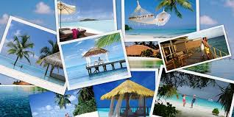
Time 2 Journey offer exclusive destinations for organizing corporate tours. Meeting, exhibitions and conferences are vital for any organizations. Companies generally conduct such events on other locations and for that it needs proper planning and execution. We value the concept of corporate tour and bring you with amazingly tailor-made tour offerings. This will surely help your employees to drain all their stress and enjoy the tour with luxury.
The diversity of designations on both national and international circuits helps us to offer exclusive tour options. We have been conducting corporate tours for our clients and were successful in gaining effective result from company and employees.
We also help in selecting ideal venue for Product launches, Seminars, Conferences, Official openings, Conventions, so you don’t have the burden and concentrate on other official things.
Also known as Incentive tours, the main aim to conduct such tours is to regain the stamina in the exhausted body enabling it to work at its best.

